Super Tic Tac Toe Project Report
An analysis of program development and design
Prepared by: Kenneth Chau, Anika Hedden, Muhammad Saffiullah
Date: November 26, 2023

Table of Contents
GitHub Links 3
Project Report 3
1. Abstract 3
2. Introduction 3
2.1 Background 4
3. Rules of The Game 5
4. The Coordinate System 8
5. Code Details 9
5.1 A Problem With the Coordinate System and Its Solution 9
5.2 A Brief Overview of What the Rest of the Code Does 13
6. GUI 14
6.1 Background 14
6.2 Structure and Code 14
6.3 Process 15
7.0 Version Control with GitHub 16
8.0 Conclusion 16
9.0 Contributions

GitHub Links
Super Tic Tac Toe Console Project
Super Tic Tac Toe GUI

Project Report

1. Abstract
For this project, we decided to make a more advanced and complex version of Tic Tac Toe. Think of this “Super Tic Tac Toe” as a regular 3x3 Tic Tac Toe with another 3x3 Tic Tac Toe inside each box. It turns into a 9x9 grid, and the rules of the game will be explained later in this report. We made a version of it that has a graphical user interface that the user can interact with just by clicking on the squares and a version that runs in the command prompt and takes in the user’s input through a keyboard. The reason we chose to make this game is because even though it already exists (it’s not our original idea), it’s not very popular and it requires more thinking and more strategy than the regular Tic Tac Toe. It’s also a fun way for the players to kill boredom or pass their time as each match takes about 15 - 20 minutes.

2. Introduction
Super Tic Tac Toe, also known as Ultimate Tic Tac Toe, represents an evolution of the regular 3x3 Tic Tac Toe game. It challenges the players to take a more strategic approach while playing it. The game consists of a grid structure where each cell/box contains another smaller 3x3 Tic Tac Toe inside of it. The goal of the game is for the player to win at least 3 of the smaller Tic Tac Toe games so that they can match up either vertically, horizontally, or diagonally to win the game as a whole.

2.1 Background
Since this is an introductory class and everyone involved in the group project is a freshman, we had a hard time deciding what would be interesting to do for this project but also not something too difficult. Initially, we considered using SFML, a cross-platform software development library, to create a roguelike game. However, due to the time constraints for this project, we decided to brainstorm other ideas. We ended up making Super Tic Tac Toe because it seemed interesting and not too well-known. We decided to use C++ Builder to make the GUI version of the game. We wrote the code for the command prompt version of the game in VS Code. When we started working on the code of the game, we realized that we needed to think critically and write algorithms for repetitive things instead of writing really lengthy blocks of code because that is inefficient. We tried not to copy any blocks of code from online sources because writing code from scratch would enhance our learning about C++ and thinking critically as well.

3. Rules of The Game
The rules of Super Tic Tac Toe seem intricate at first but they’re simple enough for everyone to understand. This is what the Super Tic Tac Toe board looks like before the game starts:
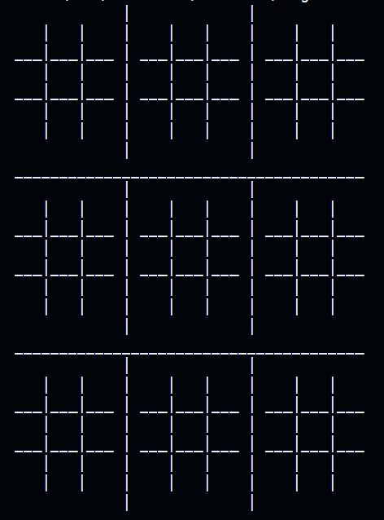

The first move played by a player is always ‘X’ and it can be played in any box of the entire 9x9 grid. The position of the next move is decided by where the first/previous move was played. For example, if the first move was played in this box:
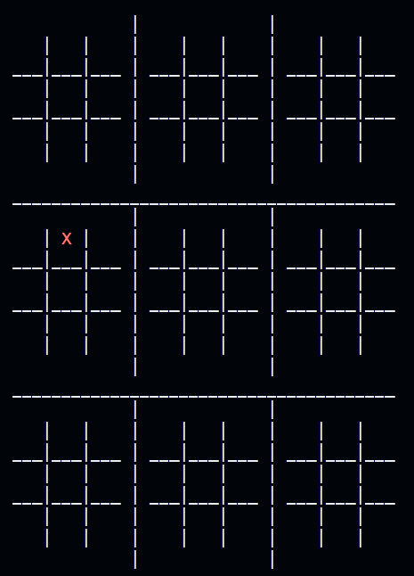

Since that ‘X’ is in the 2nd box of the small 3x3 Tic Tac Toe grid, that means the next move by ‘O’ has to be played in the second small 3x3 Tic Tac Toe grid of the main grid. It can be played in any one of these 9 boxes:

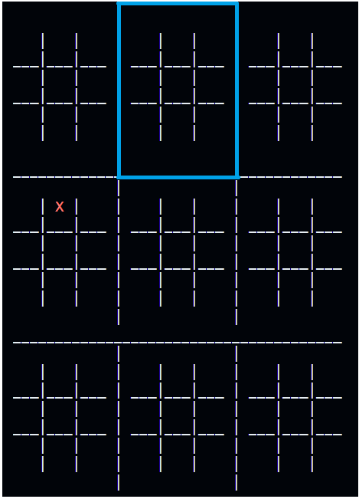

Suppose player ‘O’ plays a move in the 3rd box of that small Tic Tac Toe grid, that would mean that player ‘X’ then has to play in the 3rd small Tic Tac Toe grid of the main grid. The game continues in that pattern and the aim for both players ‘X’ and ‘O’ initially is to win the smaller 3x3 Tic Tac Toe grids.
The smaller Tic Tac Toe grids can either be drawn or won by the players. There is a different rule for when a grid has been won or drawn. For example, if grid 4 (smaller Tic Tac Toe no.4) has either been won or drawn, and player ‘O’ plays a move that would prompt player ‘X’ to play in grid 4, since grid 4 has either been drawn or won, player ‘X’ has the ability to play in any other grid of their choice.

These two processes continue until the game ends. The game ends when either player ‘X’ or ‘O’ have won 3 grids that match up either horizontally, vertically, or diagonally (like in a regular Tic Tac Toe game).

4. The Coordinate System
The coordinate system for the version of the game that works in the command prompt is based on two digits (or a two digit number). The first digit of the number represents which smaller Tic Tac Toe the player will be playing in. The second number represents which specific box in that smaller Tic Tac Toe the player wants to play the move in. For example, if player ‘X’ starts off by entering ‘42’, an ‘X’ will be placed in the 2nd box of the 4th smaller Tic Tac Toe grid as shown in the image below.
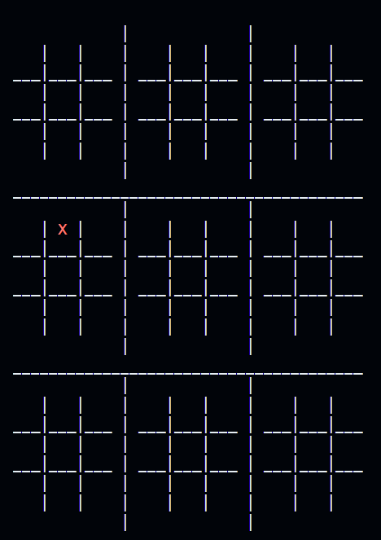

5. Code Details

5.1 A Problem With the Coordinate System and Its Solution
We encountered quite a few problems initially and had a hard time trying to find a solution for them. The main problem was figuring out the coordinate system for Super Tic Tac Toe and how to take in the inputs from the players efficiently. The coordinate system was tricky to figure out because the 9x9 grid is not actually mapped 1 to 1 on the vector that we used to print that grid and place the symbols in. That is because to make the grid look nice and neat, it needed to be formatted properly using whitespaces and those whitespaces take up memory in that vector. This is what the vector that prints the grid looks like in the code:
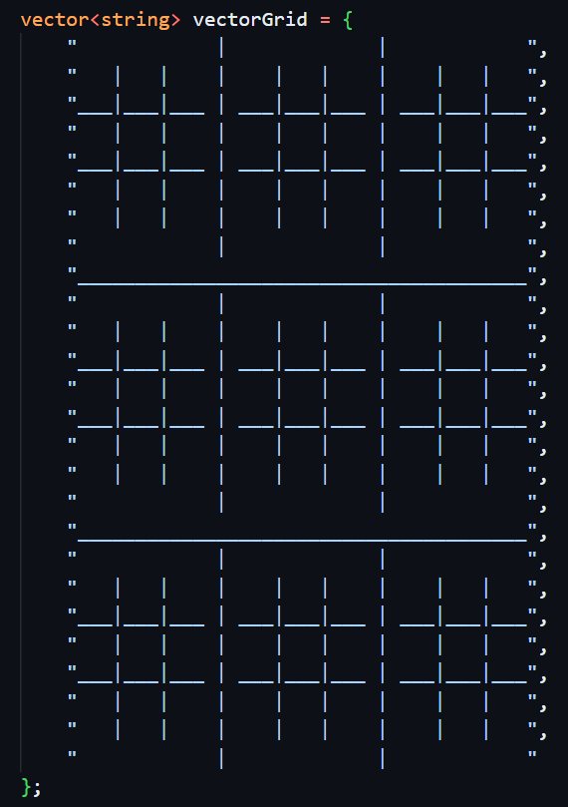

Even though this grid is supposed to be a 9x9 grid and it even looks like a 9x9 grid, it’s actually a 24x37 grid because of the whitespaces. Figuring out how to take the player’s inputs was a hassle. Initially, we turned this into a function:
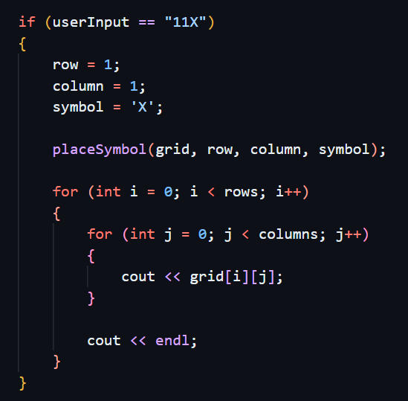
-and used a lot of if statements to place the moves in the correct places.
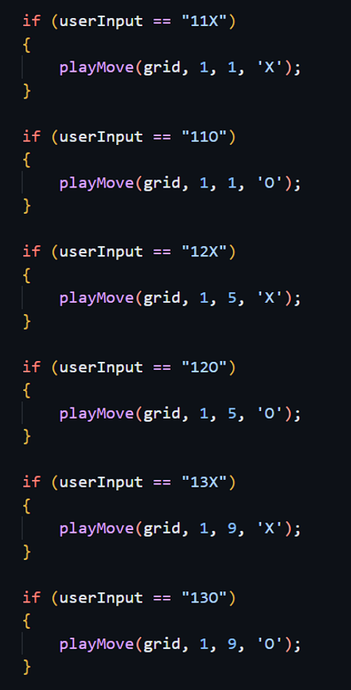
This approach was very inefficient as just taking in the inputs would have been well over a thousand lines of code. Adding the game logic would just make it even worse with this approach.

For reference, this is how the 24x37 grid is mapped:
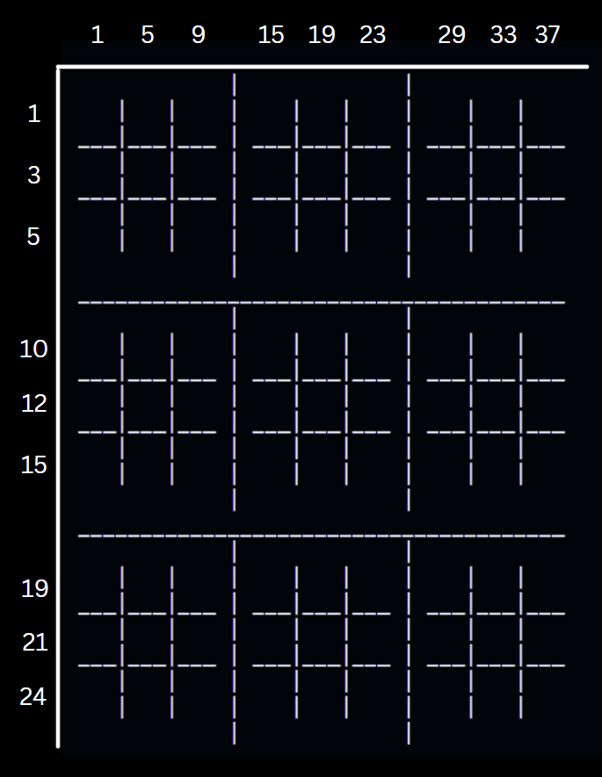
We could just ask the player to enter their move using these numbers but that would be inefficient for the player and they might lose interest in this. So, with the coordinate system we established, if a player enters 42 for example, the code converts ‘4’ to ‘10’ and ‘2’ to ‘5’ because of the way they are mapped as shown in the figure above.

5.2 A Brief Overview of What the Rest of the Code Does
The printGrid function, as the name suggests, prints the Super Tic Tac Toe grid and updates it with the player move (‘X’ or ‘O’) whenever it is called in main in the while loop. The code is written in a way that every ‘X’ in the printed grid is colored red and every ‘O’ is colored blue. The getY, getX, getActualY, getActualX functions are there to set up the coordinate system that we needed for this game. The checkWin function checks for the win in the individual 3x3 Tic Tac Toe grids. The checkWinFinal function checks the win conditions for the bigger grid when the individual 3x3 Tic Tac Toe grids have been won or drawn. The clearConsole function prints 100 new lines so that the previous grid printed in the console gets pushed behind and doesn’t interfere with the latest printed grid. The getUserInput function takes in the inputs from the players and validates whether they’re the right data type. More detailed player inputs’ validation checks are in the main function. Main also has a lot of the game logic and all of the functions mentioned above work together in main to make Super Tic Tac Toe.

6. GUI

6.1 Background
We used C++ Builder, developed by Borland and owned by Embarcadero Technologies, to develop the graphical user interface for our game. C++ Builder is a rapid application development environment (RAD) for developing software in the C++ programming language. It uses a form-based design environment and fundamentally differs from game engines like Unity. Although C++ Builder is not intended to be a game development tool, the relatively simplistic design of Super Tic Tac Toe was easily expressed using this software. Our original plan was to refactor the code for the console version and represent it using a GUI. Unfortunately, based on the foundational structure of the C++ Builder development environment, we could not use the coordinate system method in this program. Instead, we developed a different approach.

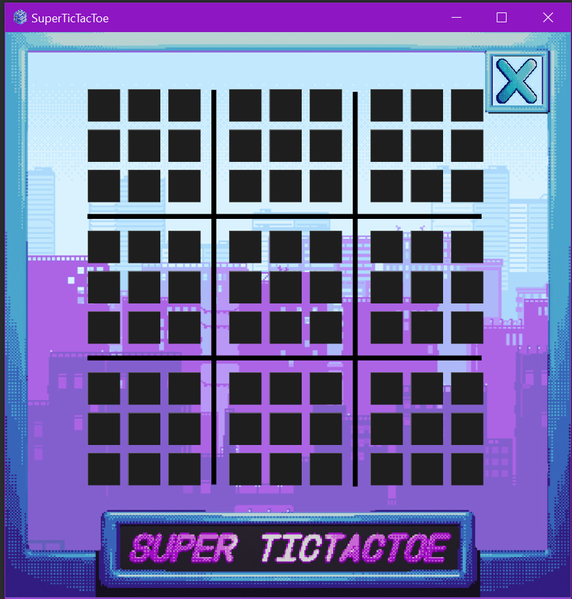
6.2 Structure and Code
The functionality of the game is based on clickable button components with boolean values. The image in the top right corner displays what the current player symbol is. As you play through the game, buttons enable and disable based on the valid moves available for your turn. Invisible panel objects prevent the player from clicking on buttons that are not playable or have already been clicked.

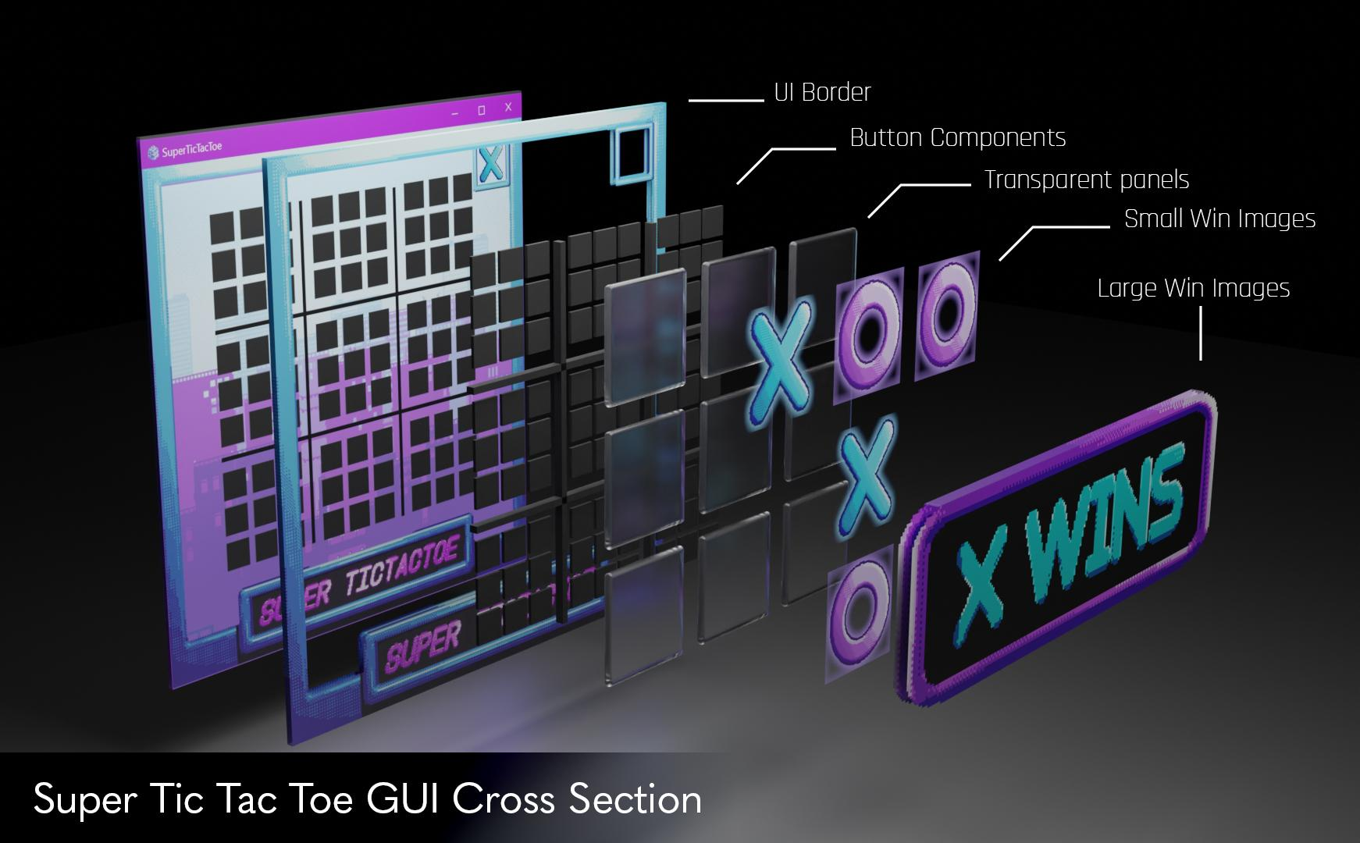

6.3 Process
First, the buttons were created with alternating X and O values. Then win conditions were made for the smaller grids. Afterward, we had to develop a simple way to determine where the player was allowed to play next. Initially, we tried enabling and disabling the buttons based on the previous move. Unfortunately, this meant that buttons that had already been clicked and “greyed out” were now modifiable. Any player could change the value of any button, completely destroying the concept of the game. To fix this, we implemented transparent panels that turned on and off based on the previous move. The panels also had a HitTest property that determined whether or not the panel blocked off the space behind it from being clicked. Once the current playable grid was determined, we implemented win functions and images for the smaller quadrants, as well as the larger quadrants.

7.0 Version Control with GitHub
For our console project and GUI project, we used GitHub to organize, manage, and share our files. We learned Git concepts like committing, pulling and pushing, and making branches. We found this version control system to be very useful and easy to understand. Three team members were able to work on the code at one time by cloning the repository and pulling to their own branch. We were able to review changes by comparing different commits on GitHub. Learning how to use Git and GitHub was a great experience, and we will certainly be using this powerful tool in the future.

8.0 Conclusion
Overall, we learned that critical thinking and problem-solving skills are a major part of program development. At times, issues seemed impossible to solve. But after either taking a short break or taking a new perspective, solutions would start to emerge. While making the GUI for our project, we were able to gain a greater understanding of classes and objects. Being able to practically use the concepts we learn in class has especially helped with abstract and functional knowledge. We also concluded that we will not be using C++ Builder for games in the future. A form designer is not set up for high levels of customization, and many of the components had to be used for their unintended purpose, leading to difficulties. Additionally, C++ Builder had very poor integration with Source Control software such as Git. We were unable to use the built-in source control process and instead had to manually commit and push changes using either the terminal or GitHub Desktop.

